

Enterprise Standards and Best Practices in IT infrastructure

4th Year, 2nd Semester, 2016

OS installation on VMware ESXi Baremetal Server

**Install and configure *Squid* server**

Submitted to

Sri Lanka Institute of Information Technology

IT13095772

Dumendra W.A.S.

In partial fulfillment of the requirements for the

Bachelor of Science Special Honors Degree in Information Technology

OS Installation

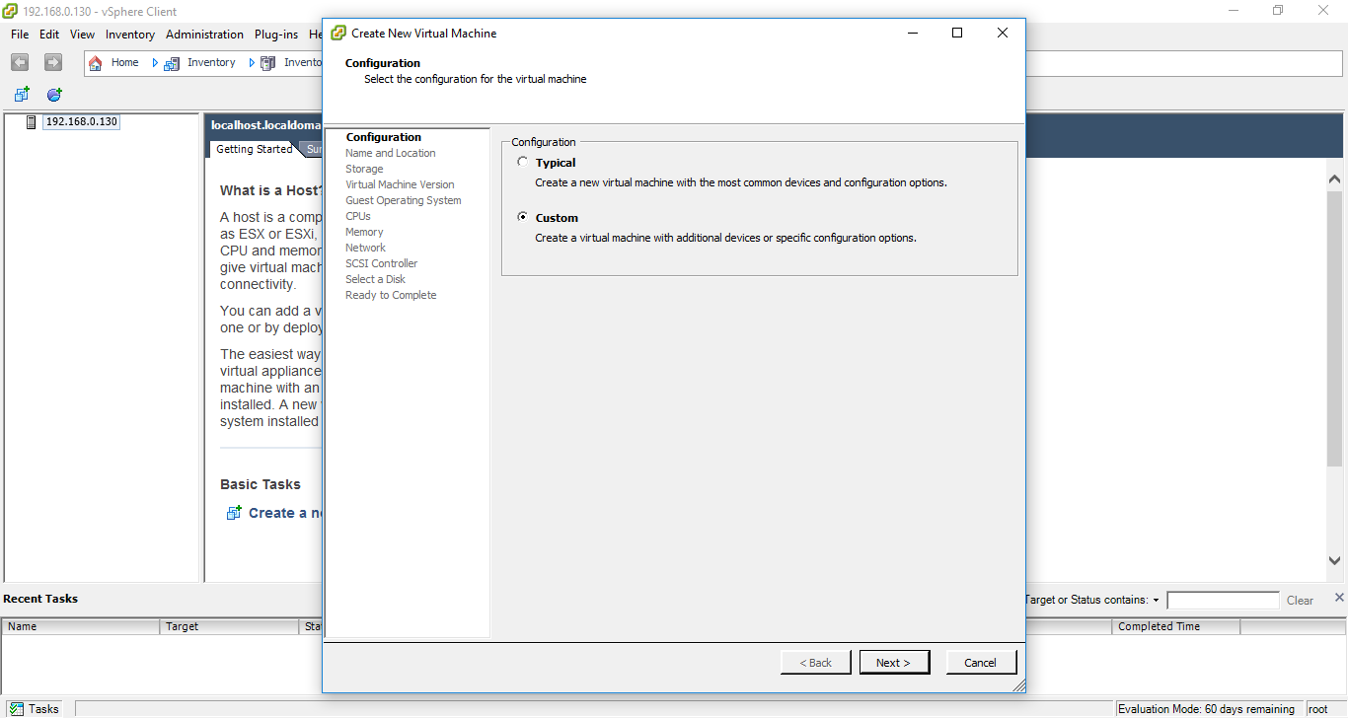

Naming the VM

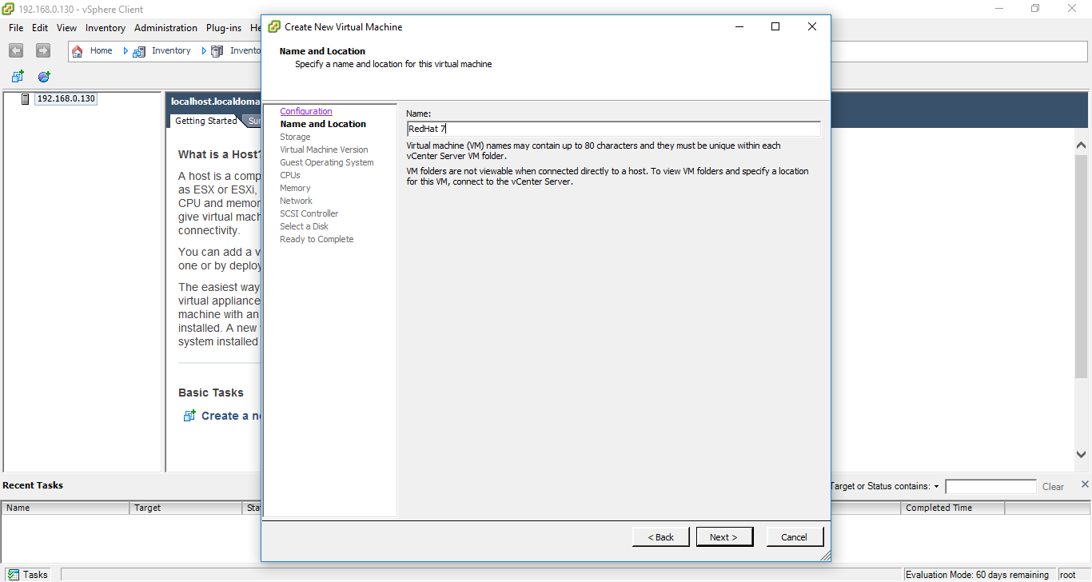

**Selecting the datastore**

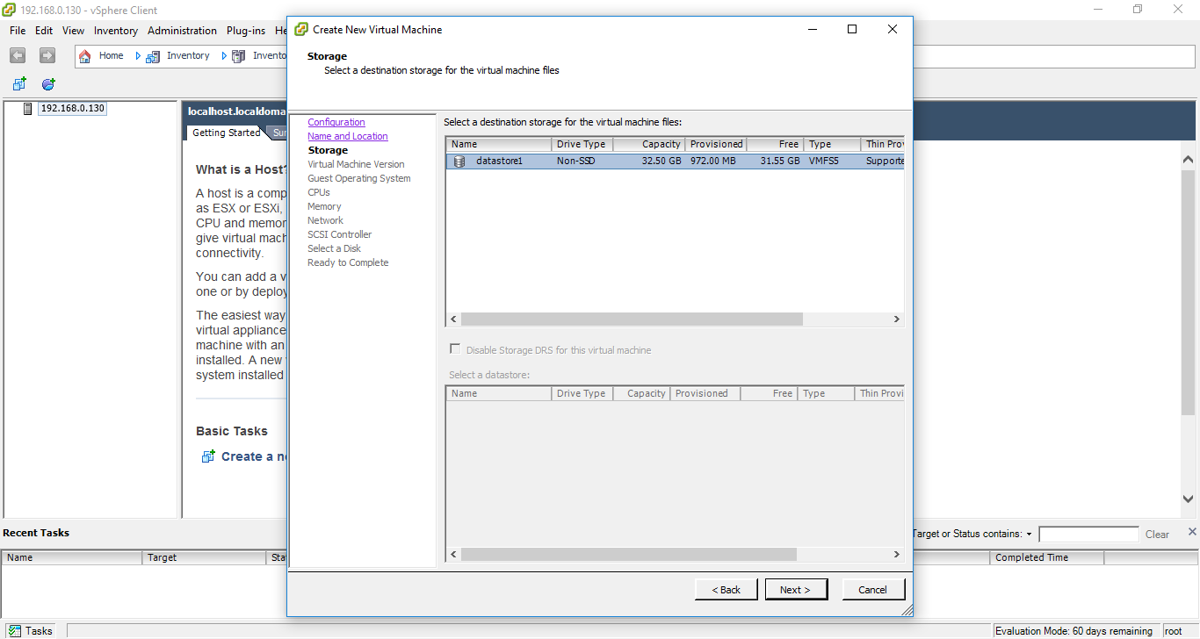

**Compatibility Mode**

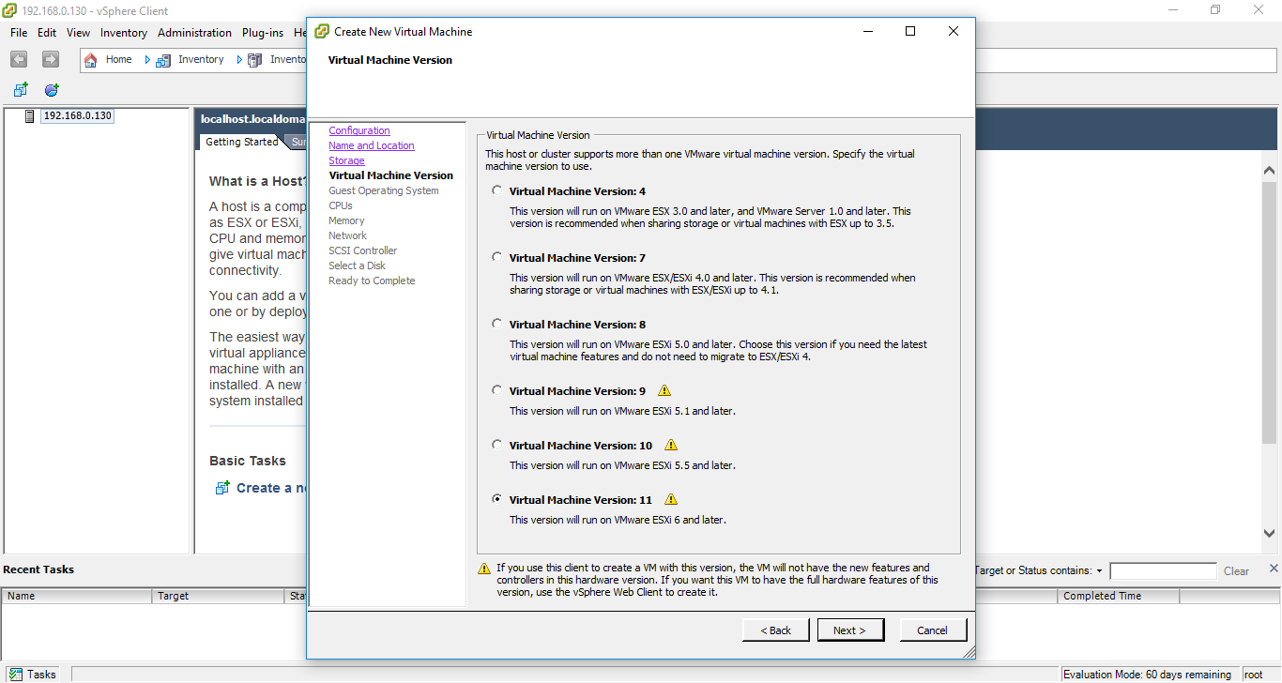

**Guest Operating System Selection**

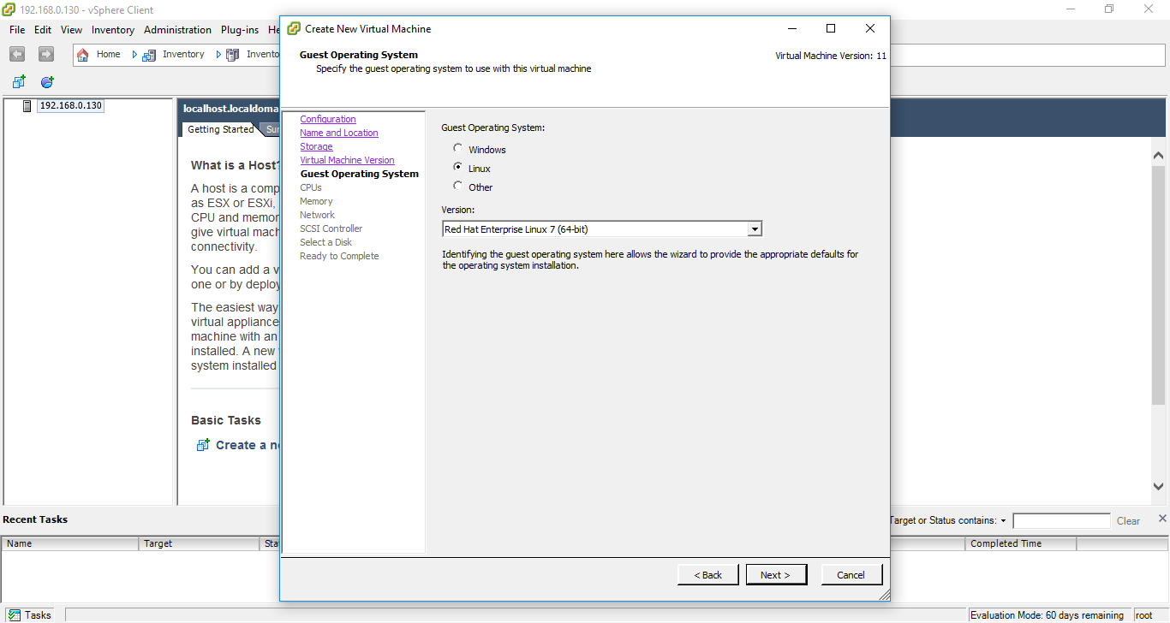

**CPUs Selection**

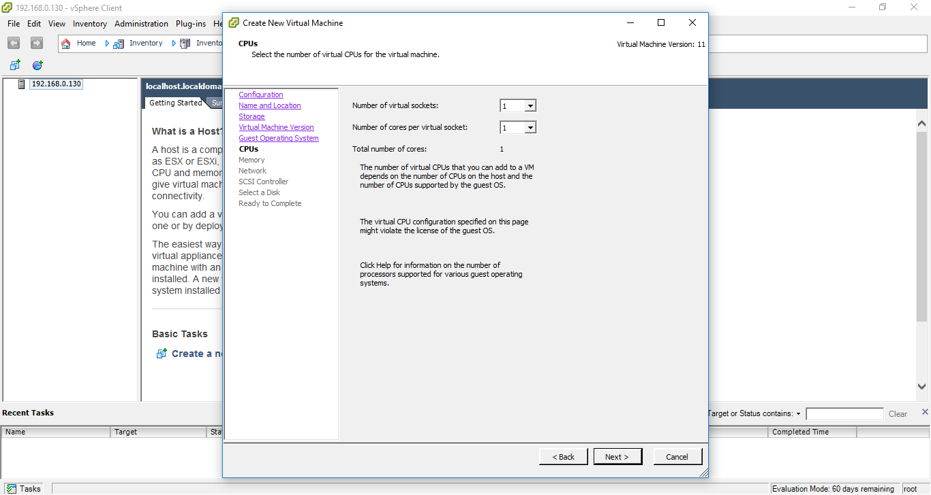

**Allocation of RAM**

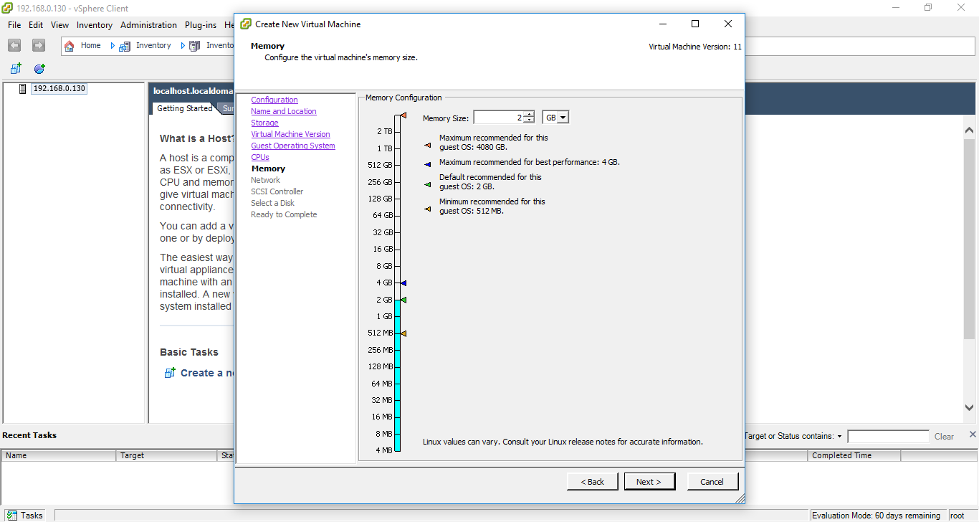

**vNIC configuration**

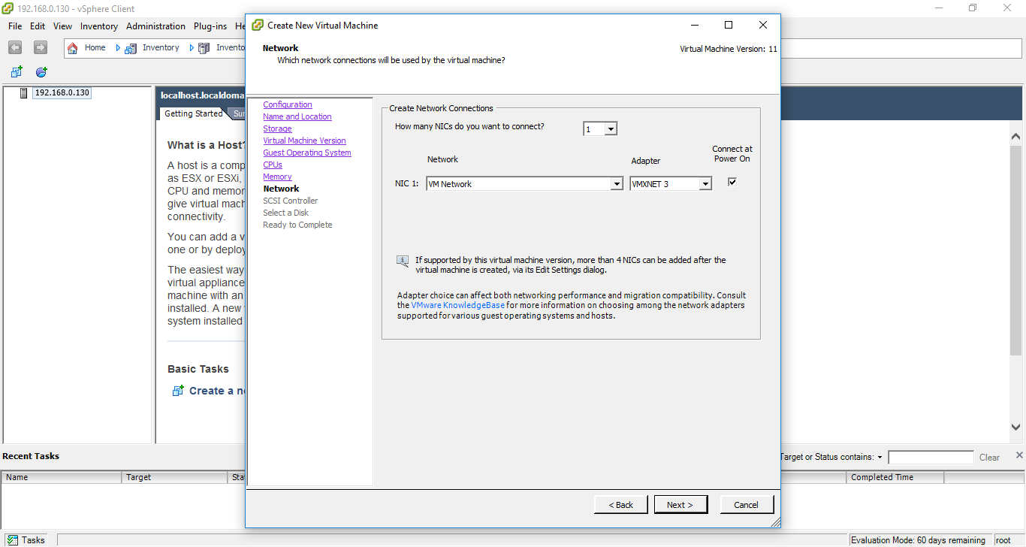

**SCSI Controller**

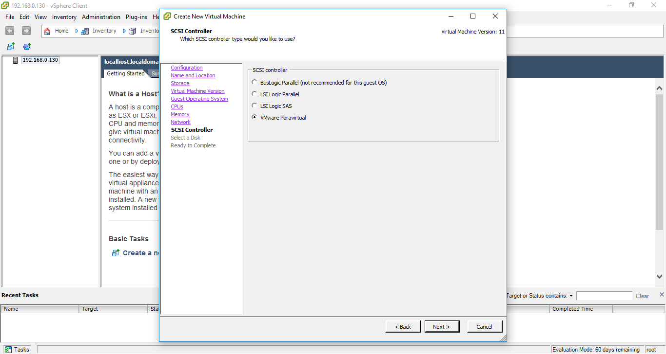

**Disk Creation**

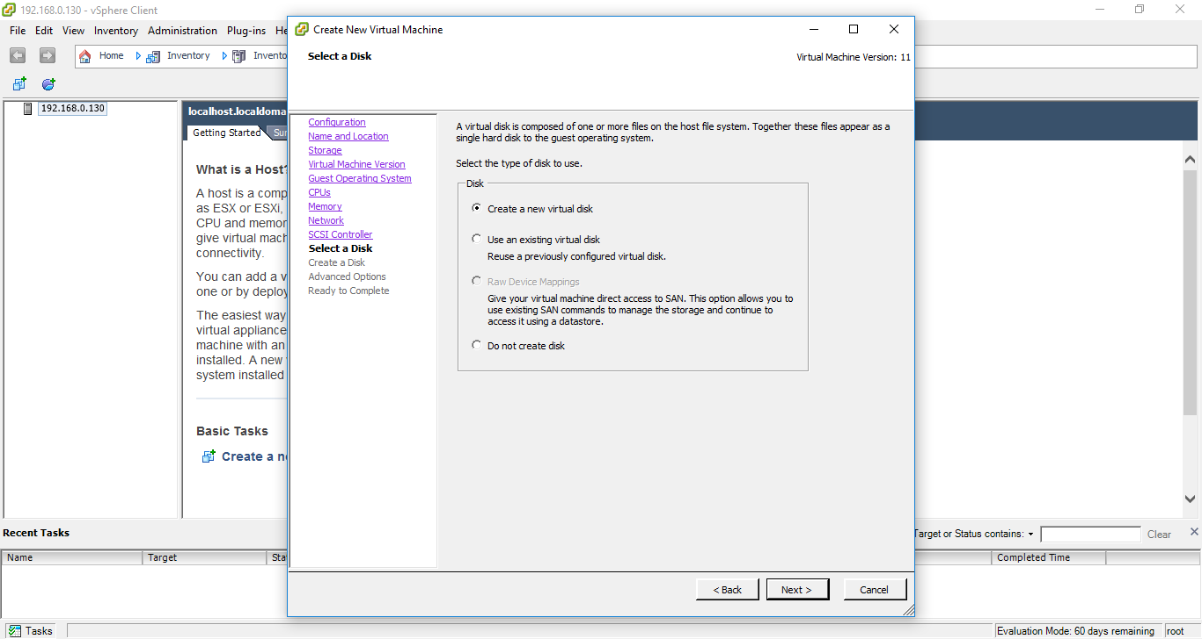

**Options for SCSI controller**

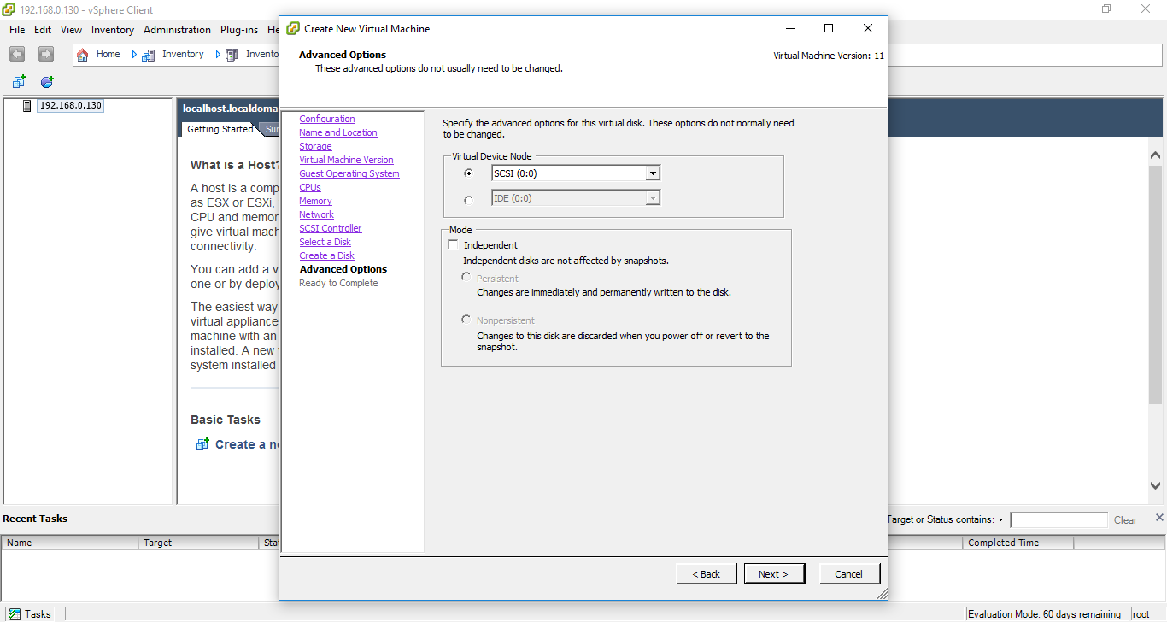

**Summary**

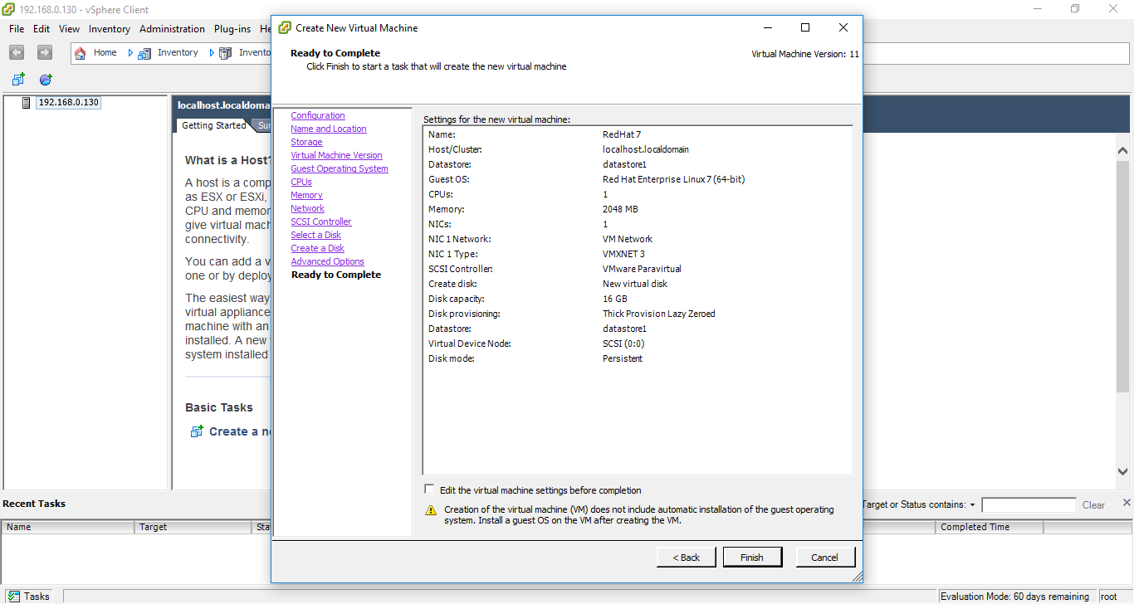

**VM on the inventory**

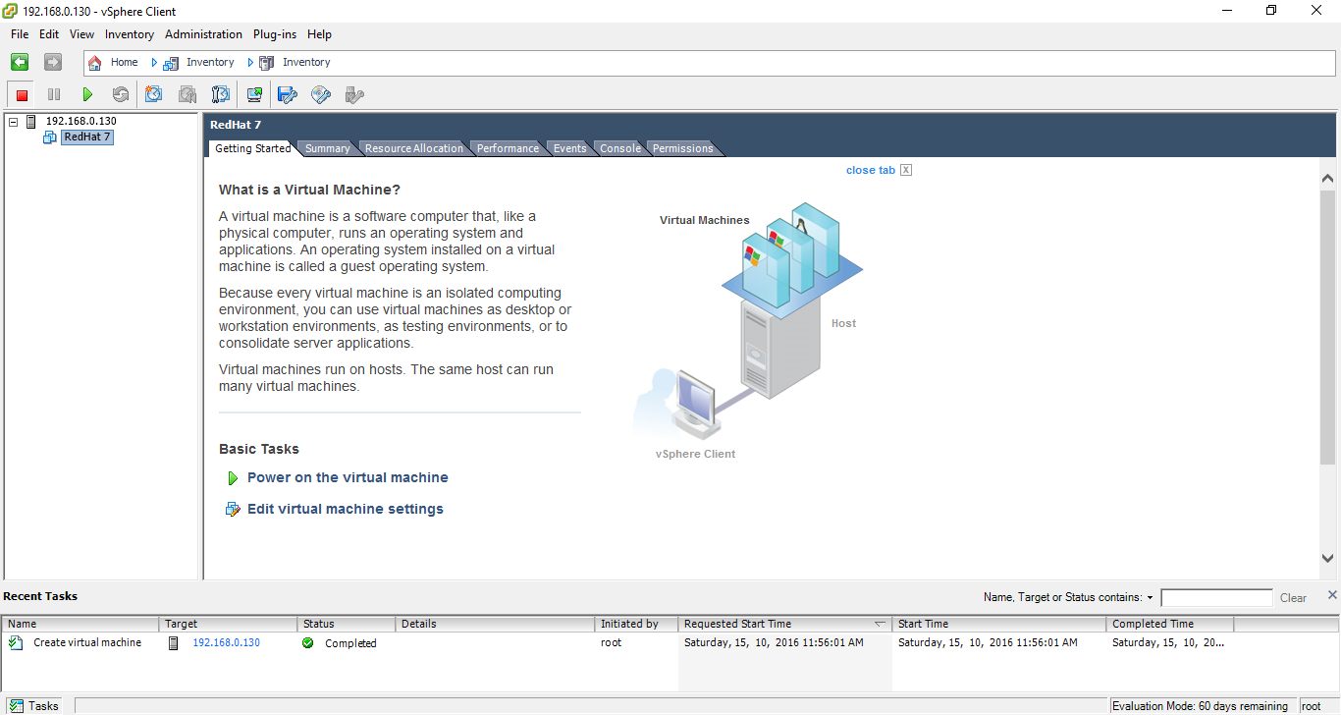

**Installation of OS**

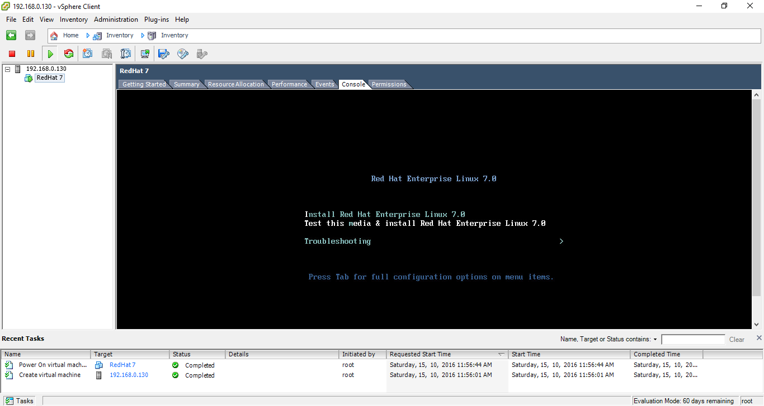

**Installation**

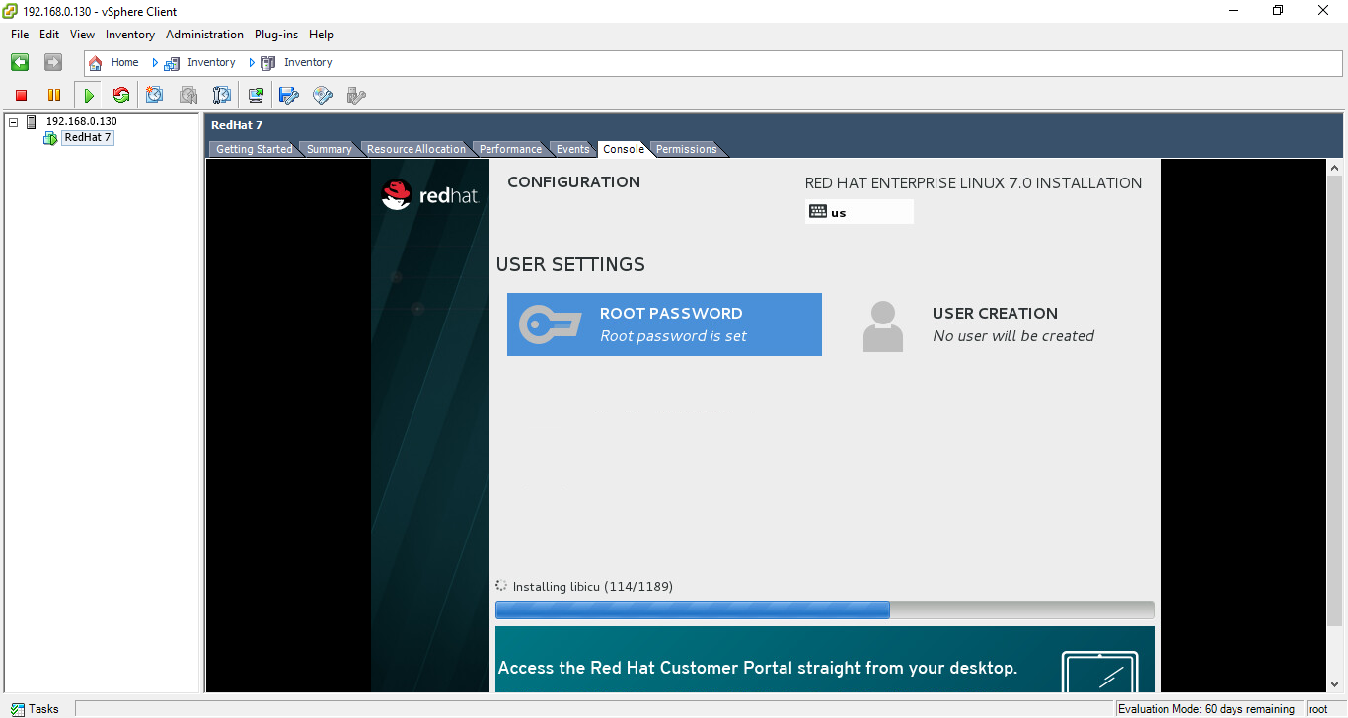

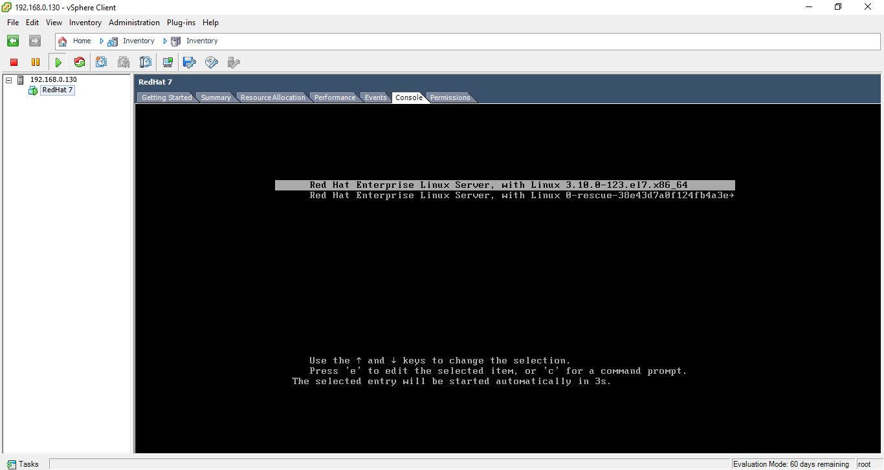

**Executing commands in the created VM**

